Mrs. Elizabeth, Mrs. Leslie, Mrs. Kelly, and Mrs. Daphne’s Weekly Buzz
September 8 – 11, 2020
What we’ve been reading…
During each story throughout the week we have been learning new vocabulary words. We’ve searched for the new words in each book, have discussed their meanings, and used them in sentences.

Miss Bindergarten Gets Ready for Kindergarten
New Vocabulary: rushes, cocoa, sneaks, and marches
Caps for Sale
New Vocabulary: peddler, infer, upset, ordinary
The Egg
New Vocabulary: definitely, longingly

Try using some of these new vocabulary words with your little ones during your everyday conversation.

Math Skills
This week we have been working on counting to 20 by ones.
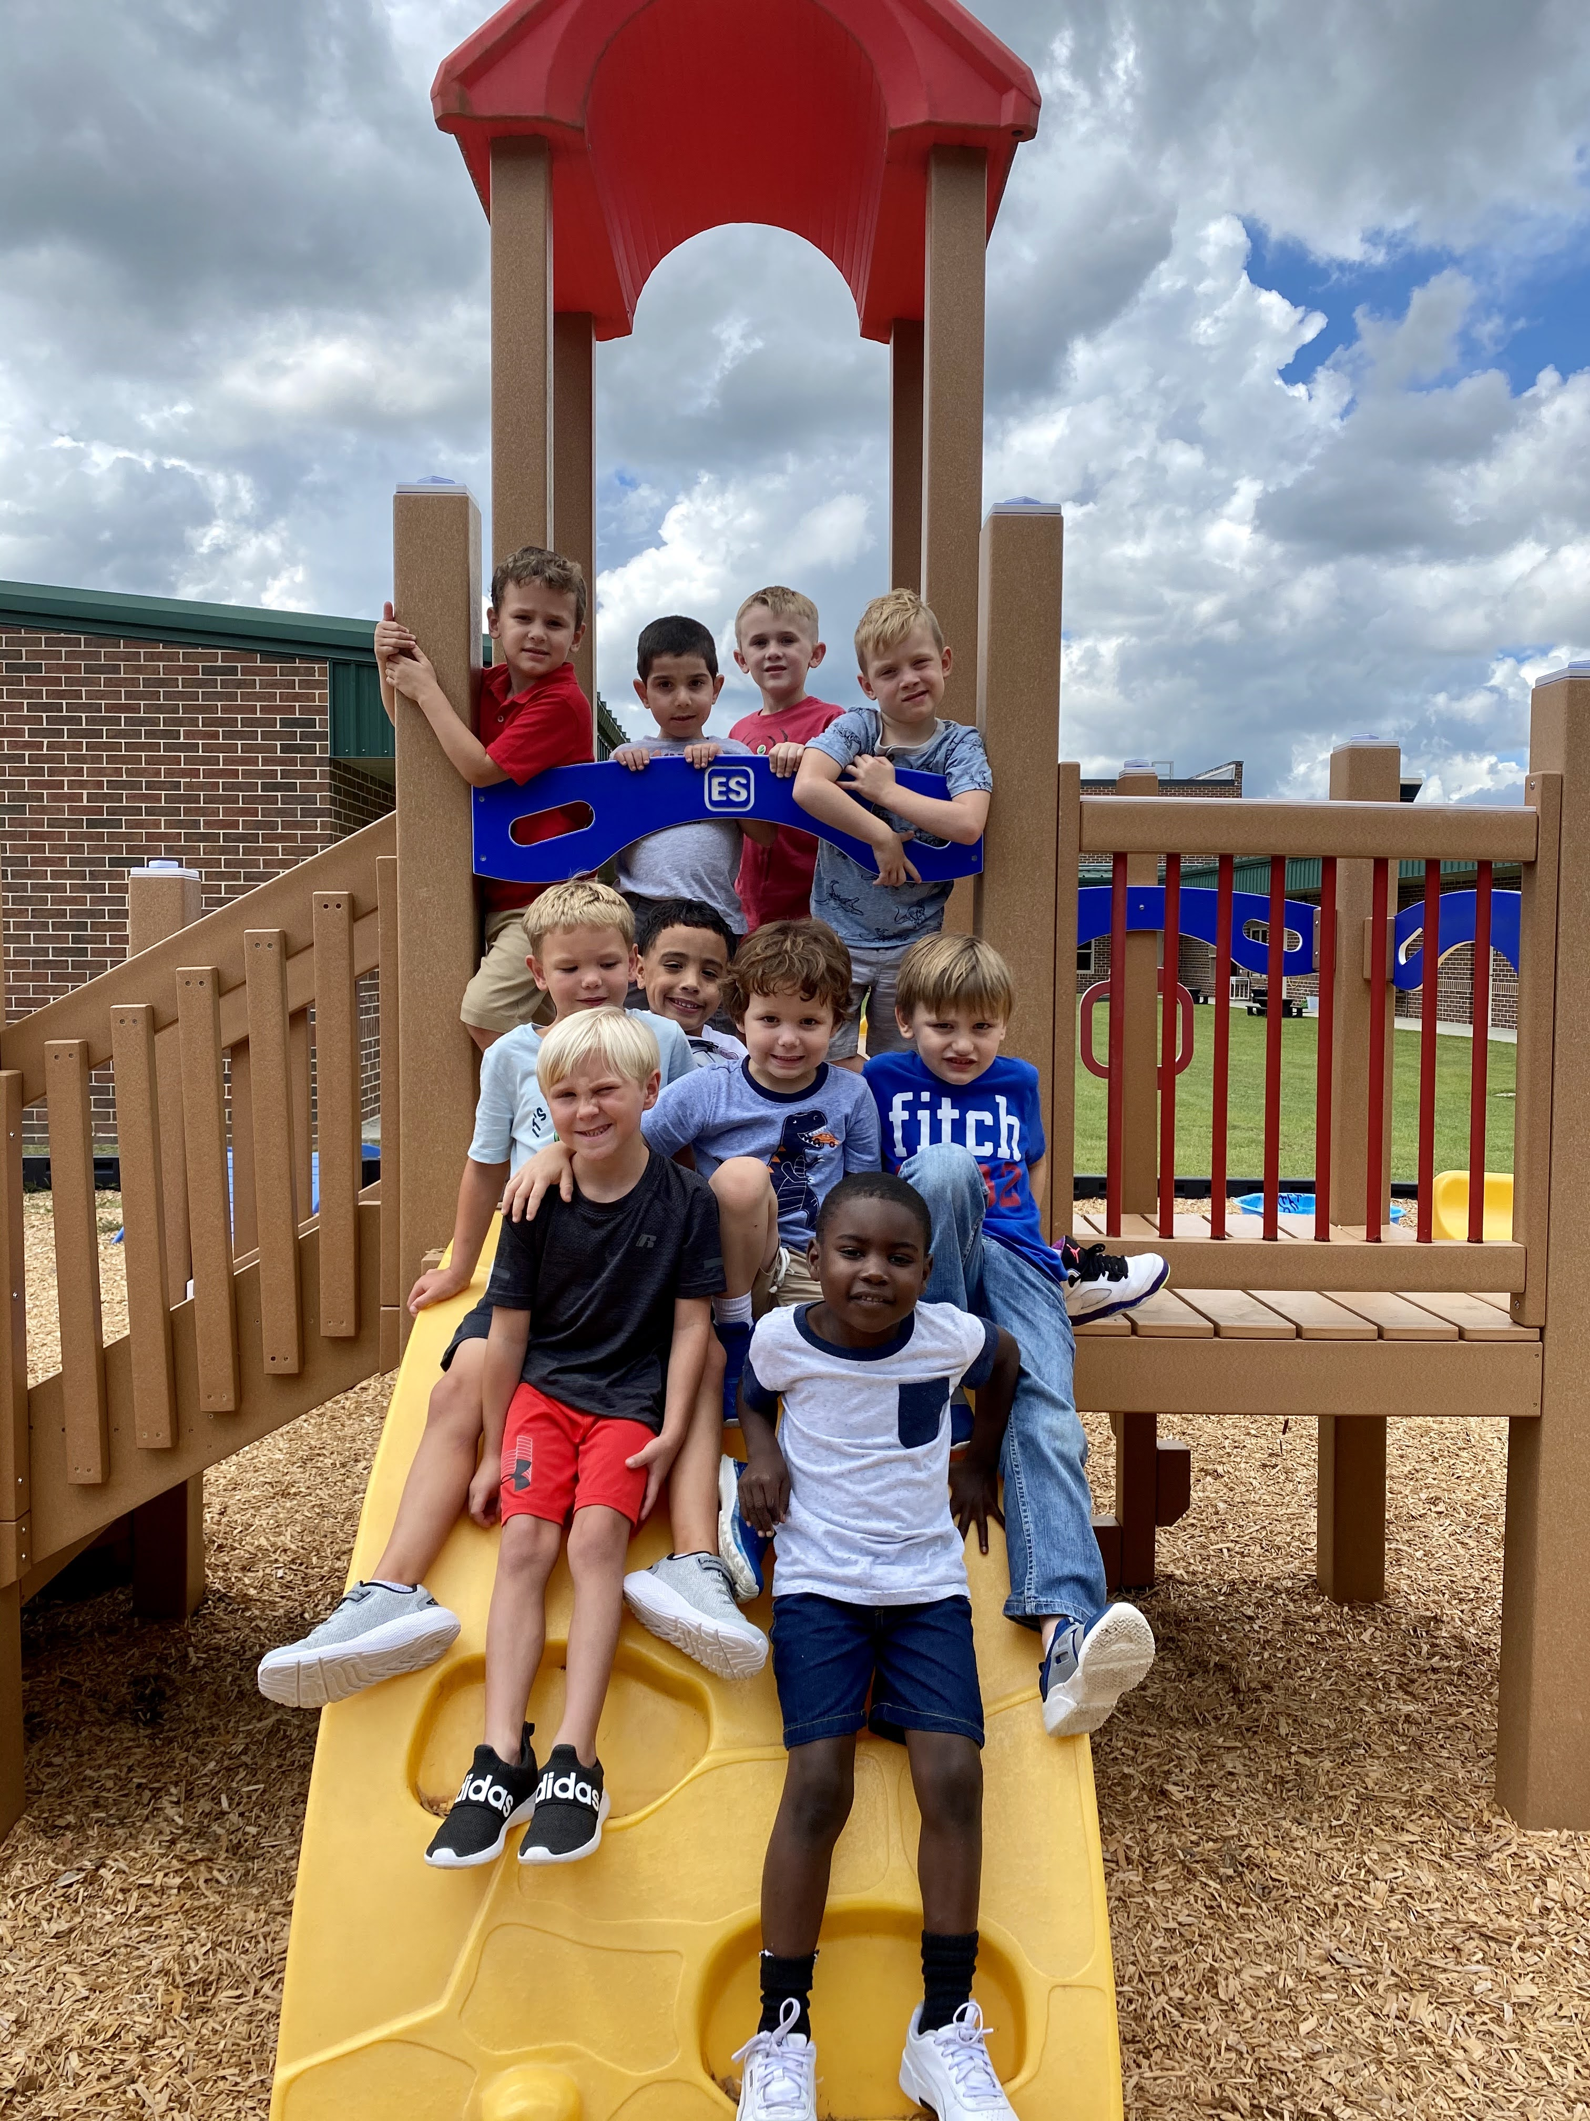
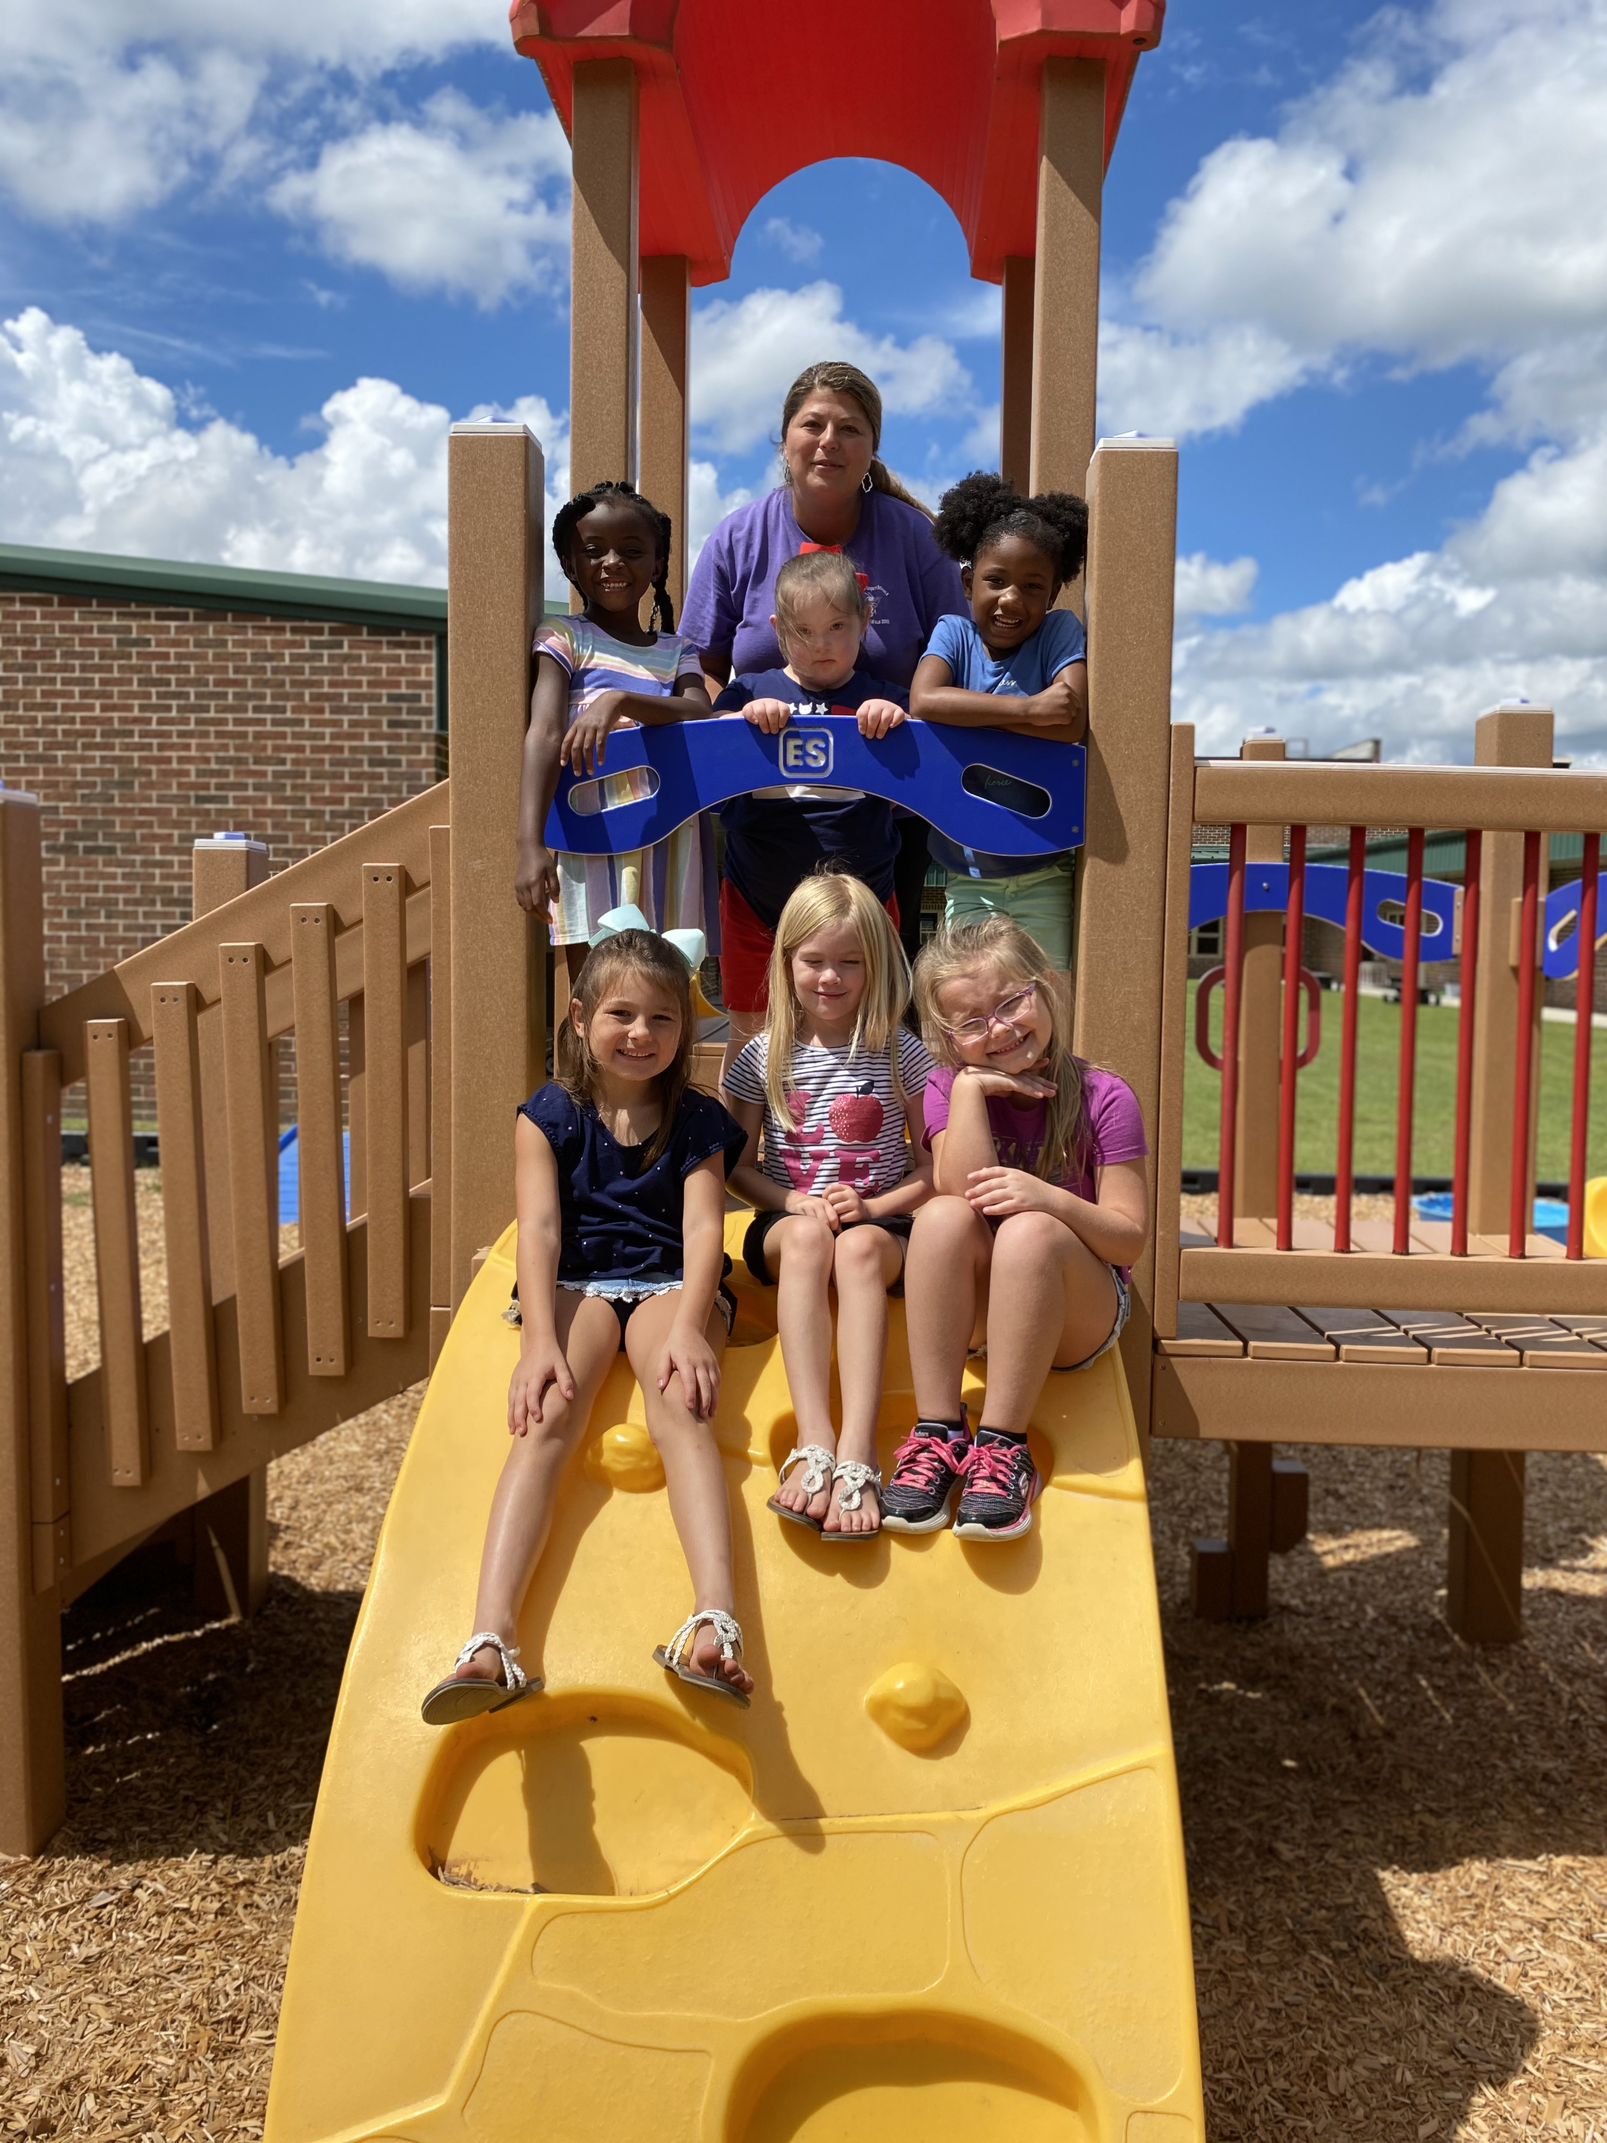
Don’t forget to send in a water bottle and mask for your little one each day!
This week we…
We had a wonderful first week in kindergarten! I can already tell that this going to be a great year! We have the sweetest group of kiddos. We have worked really hard this week learning our daily routines and responsibilities. We are really looking forward to a great year with our new school family!

